Template for Evidence(s)
UI GreenMetric Questionnaire

University : ...
Country : ...
Web Address : …
SAMPLE
[7] Governance and Digitalization (GD)

[7.18] Anti-Corruption and Integrity System of the University (GD.9)

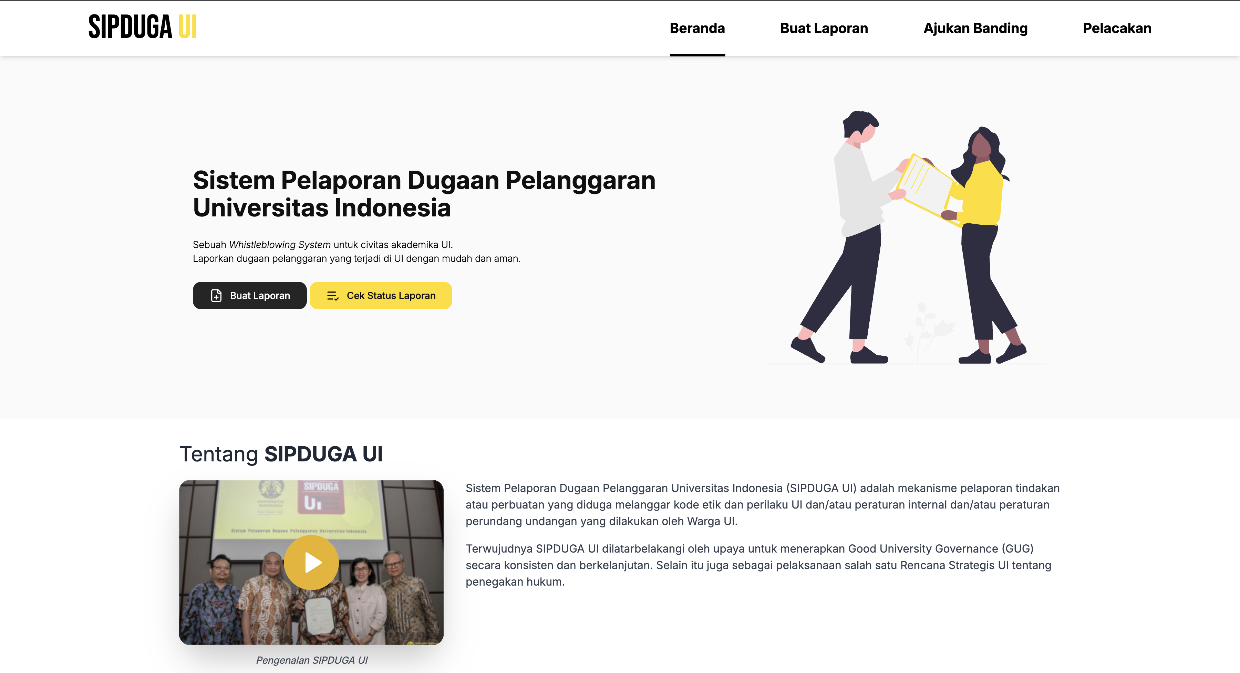Example of anti-corruption and integrity system at Universitas Indonesia (https://sipduga.ui.ac.id/)

Additional evidence link (i.e., for videos, more images, or other files that are not included in this file):

